LAKE WENATCHEE FIRE AND RESCUE AUXILIARY
14193 Chiwawa Loop Road, Box 3
(509-763-3034)

Membership Meeting Minutes
July 10, 2024 – 6:00 p.m. at Station 91

Board members present: Dorothy Baker, Liz Gilbertson, Barbara Harris, Audry Henniger, Franklin French, Kris King, and Elizabeth Pollock

Welcome: Dorothy Baker

Pledge of Allegiance

LWFR District 9:
Josiah Norby
The White Pine fire is about done. We don’t have any resources on the Shoofly fire, but DNR has a hot shot crew on it who are trying to avoid it running to Rainey pass.
The new water tender is supplying water to the helicopters. We have used the tender a lot already and are happy with it. It has many extras on it funded with money from the Auxiliary.
LWFR does not have any resources at the Pioneer Fire, and we are easily covering all the calls that come into our district.

LWFR Association:
Deb Wadkins:
We had the Association meeting last week and approved money for water pump training which will be done in October. Those attending in October will be training everyone else.
All the 50-year T-shirts and hats have been ordered and should be available by the yard sale.
Mick will advise if we are going to sell the 50th anniversary coins at the Yard Sale.

Call to Order: Dorothy Baker called the meeting to order at 6:11 pm.

Attendance: 62 members plus 1 guest were in attendance.
Please make sure you have signed in, so we are accounting for everyone who has attended. This is an important element to ensure we have a quorum per the bylaws.

New Member Introductions:
Julie and Jim Burrage are returning to the Auxiliary. Welcome back Julie and Jim!
Ruthann Halford was a guest. Welcome Ruthann!

Approve June Minutes:
Erin Colwell moved to approve the June meeting minutes, seconded by Kathleen Colvard, and the motion passed.

June Treasurer’s Report: (Barbara Harris)
Memorial Account $ 30.00
Technology Account $ 150.00
General Account
Beginning Balance June 1, 2024 $ 21,571.45
Golf Tournament Donations +$ 650.00
Transfer to Technology Account for Zoom -$ 150.00
Ending Balance as of June 31, 2024 $ 22,071.45
Stan Morgan moved to approve the June Treasurer’s report, seconded by Chris King, and the motion passed.

Old Business:
Bylaws: Dorothy Baker
As outlined in the new bylaws, the requirement for a quorum is 25% of the membership and this is the reason accurate attendance is important. We need 40 people at the meetings to make motions etc. and this includes zoom members as well.

Airlift NW and Life Flight: Barbara Harris
The deadline for Airlift NW and Life Flight registration is at the August membership meeting on August 14th. To register for both, it is $123.00.

Committee Reports:
Facilities: Scott Baker
I want to thank all the facilities and social committee people who helped put this July BBQ and potluck event on.

New Business:
Technology Account: Barbara Harris
The technology Account was created for an Auxiliary Zoom account where a debit card is used for payments. This debit card is not linked to the Auxiliary general account and cannot be overdrawn. Thank you to Liz Gilbertson for getting this set up.

Muchen Haus Event and Donations: Anita Johnson
It was very successful and lots of Auxiliary members came in their swag. Thank you to all the volunteers. München Haus said we were the most well attended and supported event.
München Haus: $2,470.00
Donations: $ 818.85
TOTAL $3,288.85
Also, a big thank you to Anita Johnson for her leadership on this event!

Free Home Assessments: Kris King
LWFR offers free wildfire assessment where they walk around the outside of your home and give pointers to help increase the chance of your home surviving if a wildfire comes through. Sign up at LWFR.org on the main page.

Smoke Alarms: Josiah Norby
LWFR offers free battery powered smoke alarms, and we will mount them for you. We can check smoke alarms and replace batteries as well. Sign up at lwfr.org under the "Public Resources" tab.

Upcoming Events:
Yard Sale: Velda Millard
Reminder August 3rd is the next drop off day and it will be from 8:30 to 11:00. Volunteers are asked to be there from 8:00 to 11:30.
Set up days are Thursday (8/29) from 11:00 - 3:00pm and Friday (8/30) from 9:00 – 3:00pm. Friday will also be a drop off day. We are still looking for leads for kitchen, tools, books, furniture and sporting goods so please let me know if you would like to be a lead. Area leads would like to have someone shadow them. For Yard Sale days, please wear your neon green shirts.

Bake Sale: Donnarae Holloway
LWFR Auxiliary aprons are $12.00 each if you are interested in purchasing one.
We have cupcake holders and containers if you would like to use these for your baked goods.
On Friday (8/30), our set up day, we can put things into the containers as we have cupcake containers, cookie bags, and bread bags.
Baked goods are popular so if you haven’t signed up yet, please do so.
At the August meeting, we will finalize the list and make sure we have enough bags etc. We will offer the pie pans again and are looking for more pie pans. If you have some, please bring them to the August meeting.
Most popular items are breads, focaccia, loaves, pies, and cookies.

Kahler Mountain Club Ladies Golf Tournament: Elizabeth Pollock
The tournament is on Tuesday, July 16th. Thanks to those who have volunteered to help. Looking forward to the event.

Sunshine Report: Sharyl Nelson
Sharyl advised that no cards had been requested to be sent out.

Good of the Order:
A big thank you to Scott Baker and Randy Pollock for BBQing the hamburgers.

If people would like to donate to the Auxiliary via Venmo, please see the information below:

There are three ways three ways to find the profile to be able to donate whenever folks want:
- Search in Venmo: "Chelan County Fire District #9 Auxiliary"
- Search in Venmo: @LWFRAuxiliary
  - Must have the @ sign and no spaces - this is the "handle"/username of the account
- Scan the QR code attached (easiest option)
  - These codes are also on our new communication board and hopefully should be printed out/available at all our fundraisers going forward
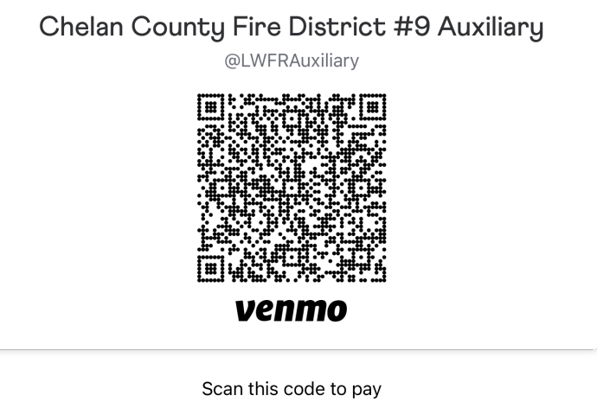

Cashiers at the Yard Sale will ask for verification on Venmo so we can know the amounts.

Next Meeting:
The next Auxiliary meeting is on Wednesday, August 14th, at Station 93. The ice Cream Social will be at 5:00 p.m., followed by the meeting, new vehicle ribbon cutting ceremony, and Jerry Jennings Memorial Garden Dedication at 6:00 p.m. There will not be a Zoom option available. Please bring a lawn chair.

The meeting concluded at 6:40pm.

Chris King moved to adjourn the meeting, seconded by April Adamson, and the motion passed.

Note: If you want to look at past minutes, they are located online, and the path is below:
LWFR.org: About LWFR: Auxiliary; Member Login (bottom of page); Auxiliary Login; Password is Auxmember18; Minutes. It shows minutes since 2010 along with the Bylaws and Articles of Incorporation.

